Accommodation Period
11 Jun 2015 - 15 Jun 2015
Package Inclusion
- 4 Night’s Accommodation
- Return Airport Transfer

FROM
MYR 829/-
Per pax (twin sharing)
MYR 1,658/-
Per pax (single)

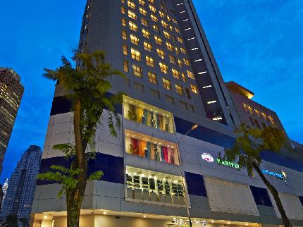

StarPoints Hotel Kuala Lumpur (3 Star) ideally located at the edge of the city centre , surrounded by major public highways, making it easily accessible for entering and exiting the city at any time of the day. This section of the city has no parallels when it comes to shopping havens and a wide variety of local and international specialty restaurants and cafes. When the sun sets, there is a burst of activities on the streets which will definitely arouse the curiosity of travelers, with music and the aroma of food filling the air.

ROOM TYPE | SINGLE | TWIN SHARING
SUPERIOR | 1 x ADULT @ MYR 1,658.00 | 1 x ADULT @ MYR 1,658.00
 | 1 x ADULT @ MYR 180.00 ADDITIONAL NIGHT | 1 x ADULT @ MYR 180.00 ADDITIONAL NIGHT
DELUXE | 1 x ADULT @ MYR 1,902.00 | 1 x ADULT @ MYR 1,902.00
 | 1 x ADULT @ MYR 245.00 ADDITIONAL NIGHT | 1 x ADULT @ MYR 245.00 ADDITIONAL NIGHT
EXECUTIVE DELUXE | 1 x ADULT @ MYR 2.43800 | 1 x ADULT @ MYR 2.43800
 | 1 x ADULT @ MYR 390.00 ADDITIONAL NIGHT | 1 x ADULT @ MYR 390.00 ADDITIONAL NIGHT
FOR RESERVATIONS CLICK HERE
Booking Conditions:
- All Prices are quoted in Malaysian Ringgit (MYR)
- Prices displayed are inclusive of surcharges and taxes at time of booking
- All timings shown are in local city times
- The final price will be displayed once you have selected your preferred package options
- Prices are not guaranteed until payment in full is received and Travel Voucher(s) are issued
- Prices are subject to change and availability at time of booking

Terms & Conditions apply. Please check the details from your Travel Advisor
B-3A-12,Level 6, Block B, Menara Uncang Emas 3 (UE3)
85,Jalan Loke Yew, 55200 Kuala Lumpur, MALAYSIA
Tel: 603-9285 3755 / 9286 8755 Fax: 603- 9285 5755
E-mail: altair@acealtairtravels.com
Web: www.acealtairtravels.com

